**Tesla Coil Guitar Amp**

A New Outlet for Artistic Expression

Authors:

David Mengel

Griffin Rzonca

Final Report for ECE 445, Senior Design, Fall 2023

TA: Jason Paximadas

6 December, 2023

Project No. 13.

**Abstract**

The tesla coil guitar amp is a device that allows users to use live input from a guitar to play music with sparks made from a tesla coil. This generates dazzling visuals and provides interesting audio effects, providing musicians a new outlet for artistic expression. The project utilizes an entirely new coil driver circuit as far as the authors can determine, minimizing switch stress and increasing efficiency when compared to traditional tesla coils. Furthermore, the project employs a novel audio processing technique by using pulse-width modulation (PWM) to drive the coil, another never done before technique as far as the authors could determine. The project was a complete success, allowing users to play music with the sparks generated from a tesla coil.

**Table of Contents**

**1 Introduction 4**

1.1 Problem 4

1.2 Solution 4

1.3 Visual Aid 4

1.4 High-Level Requirements 5

**2 Design 6**

2.1 Block Diagram 6

2.2 Audio Processing Subsystem 6

2.3 Power Subsystem 9

2.4 Switching Subsystem 9

2.5 Coil Assembly Subsystem 11

2.6 Tolerance Analysis 13

3. Design Verification 15

3.1 Power Subsystem 15

3.2 Switching Subsystem 15

3.3 Coil Assembly Subsystem 16

3.4 Audio Processing Subsystem 18

4. Costs 20

4.1 Parts 20

4.2 Labor 21

5. Conclusion 22

5.1 Ethical considerations 22

5.2 Safety 22

5.3 Accomplishments 23

5.4 Future work 23

References 24

Appendix A Requirement and Verification Table 24

# 

Figure 1: Final Product.

# 1 Introduction

## 1.1 Problem

Musicians are known for their affinity for flashy and creative displays, especially during their live performances. One of the best ways to foster this creativity and allow artists to express themselves is a new type of amplifier that is both visually stunning and sonically interesting. Musical tesla coils have been used for performances in the past, showing there is a market for such devices [1] . However, these tesla coils often use premade music files or are computer-controlled, and do not have the ability to take live input from instruments. Giving these coils the ability to take live input from a musician to create music will open up a new world of possibilities for musical expression and exciting live performances.

## 1.2 Solution

Our design is a device that uses a guitar to control a tesla coil, creating sparks that vary in tone as different notes on the guitar are played. The device consists of several key systems: an audio processing board, power supply, switching module, and coil assembly. Each system will be discussed further in the design section of this report.

## 1.3 Visual Aid

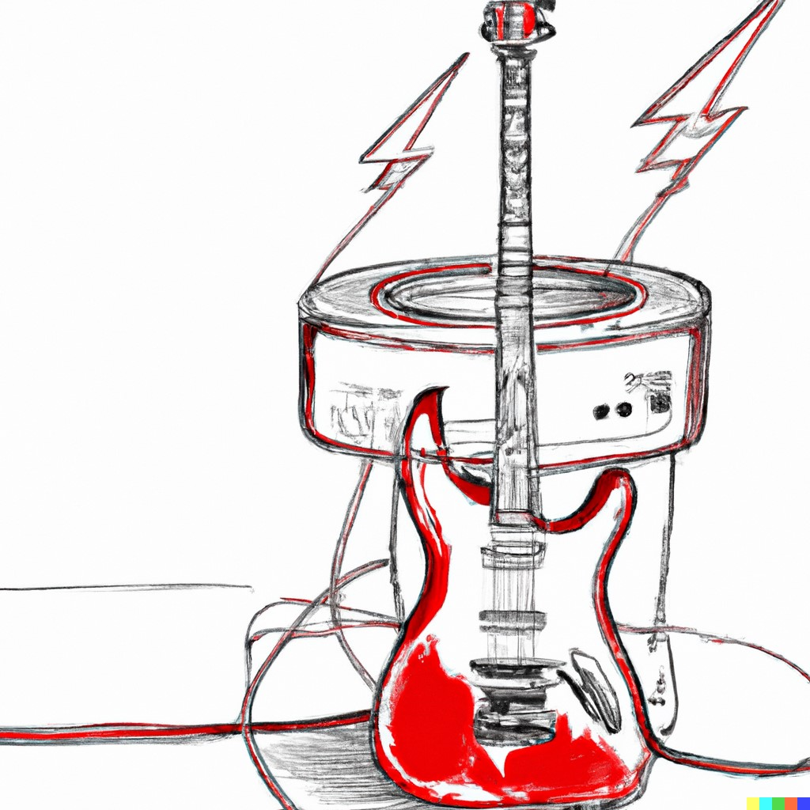

Figure 2: Concept Sketch of the Tesla Coil Guitar Amp.

## 1.4 High-Level Requirements

There were three primary requirements that this design needed to fulfill in order to be considered successful:

1. The tesla coil can produce visible sparks roughly 3-5 cm in length
2. The coil can produce several different notes in the range 50 Hz - 2 kHz
3. The coil can take input from the guitar to determine the notes played

As will be discussed in later sections, the design met all of these requirements specified to be considered a success.

# 2 Design

## 2.1 Block Diagram

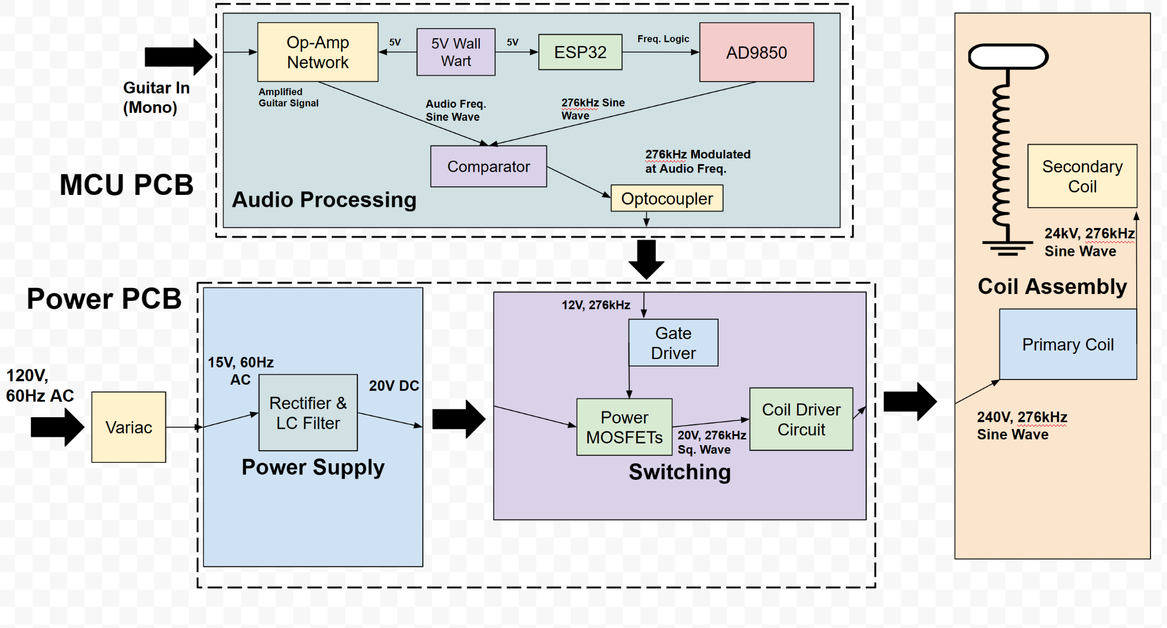

Figure 3: Functional Block Diagram of the Design.

## 2.2 Audio Processing Subsystem

The audio processing subsystem was designed to convert the output signal of the guitar into a pulse wave that controlled the MOSFETs, ultimately allowing power to be passed into the coil at the desired frequency. This was accomplished using a network op-amps for input processing, a microcontroller and frequency driver for high-frequency generation, and a comparator for generating a PWM waveform. In order for our tesla coil to create sparks, it needs to operate at its resonant frequency. Through experimentation, we found this value to be around 276 kHz. We used the ESP32 microcontroller to send a signal to an AD9850 frequency generator in order to create signals at the resonant frequency. This whole system occupied its own dedicated PCB, and was then connected to the power system PCB via a coaxial cable.

The system operates by taking the guitar input through an audio jack, amplifying this signal and adding DC bias using an op-amp network. This amplified and shifted signal is sent into one terminal of a comparator. Next, the ESP32 is used to send a signal to the AD9850 telling it to generate a sine wave at the resonant frequency, which is sent into the other terminal of the comparator. In order to output different notes, we used pulse-width modulation (PWM) to modulate a pulse wave at the resonant frequency with the audio signal. This output is then used to control the gate driver on the power board, switching both MOSFETs. This strategy is different from many other designs. Traditionally, musical tesla coil designs will use a logical AND to combine a pulse wave audio signal and a pulse wave at the resonant frequency, creating audio frequency bursts. This is effective, but the output can only be a pulse wave in the audio domain, reducing fidelity. By using PWM, our output recreates the input signal by varying output voltage quasi-linearly with the input signal. This leads to a higher audio fidelity at the output when compared to traditional designs.

Before the output signal is sent to the power board, it goes through an optocoupler for isolation. This device protects the user in the event of an overvoltage, preventing any surges of power to travel up the circuit and harm the user. Once the signal is sent through the optocoupler, it is sent to the gate drivers via a coaxial cable in order to control the switching of the power MOSFETs.

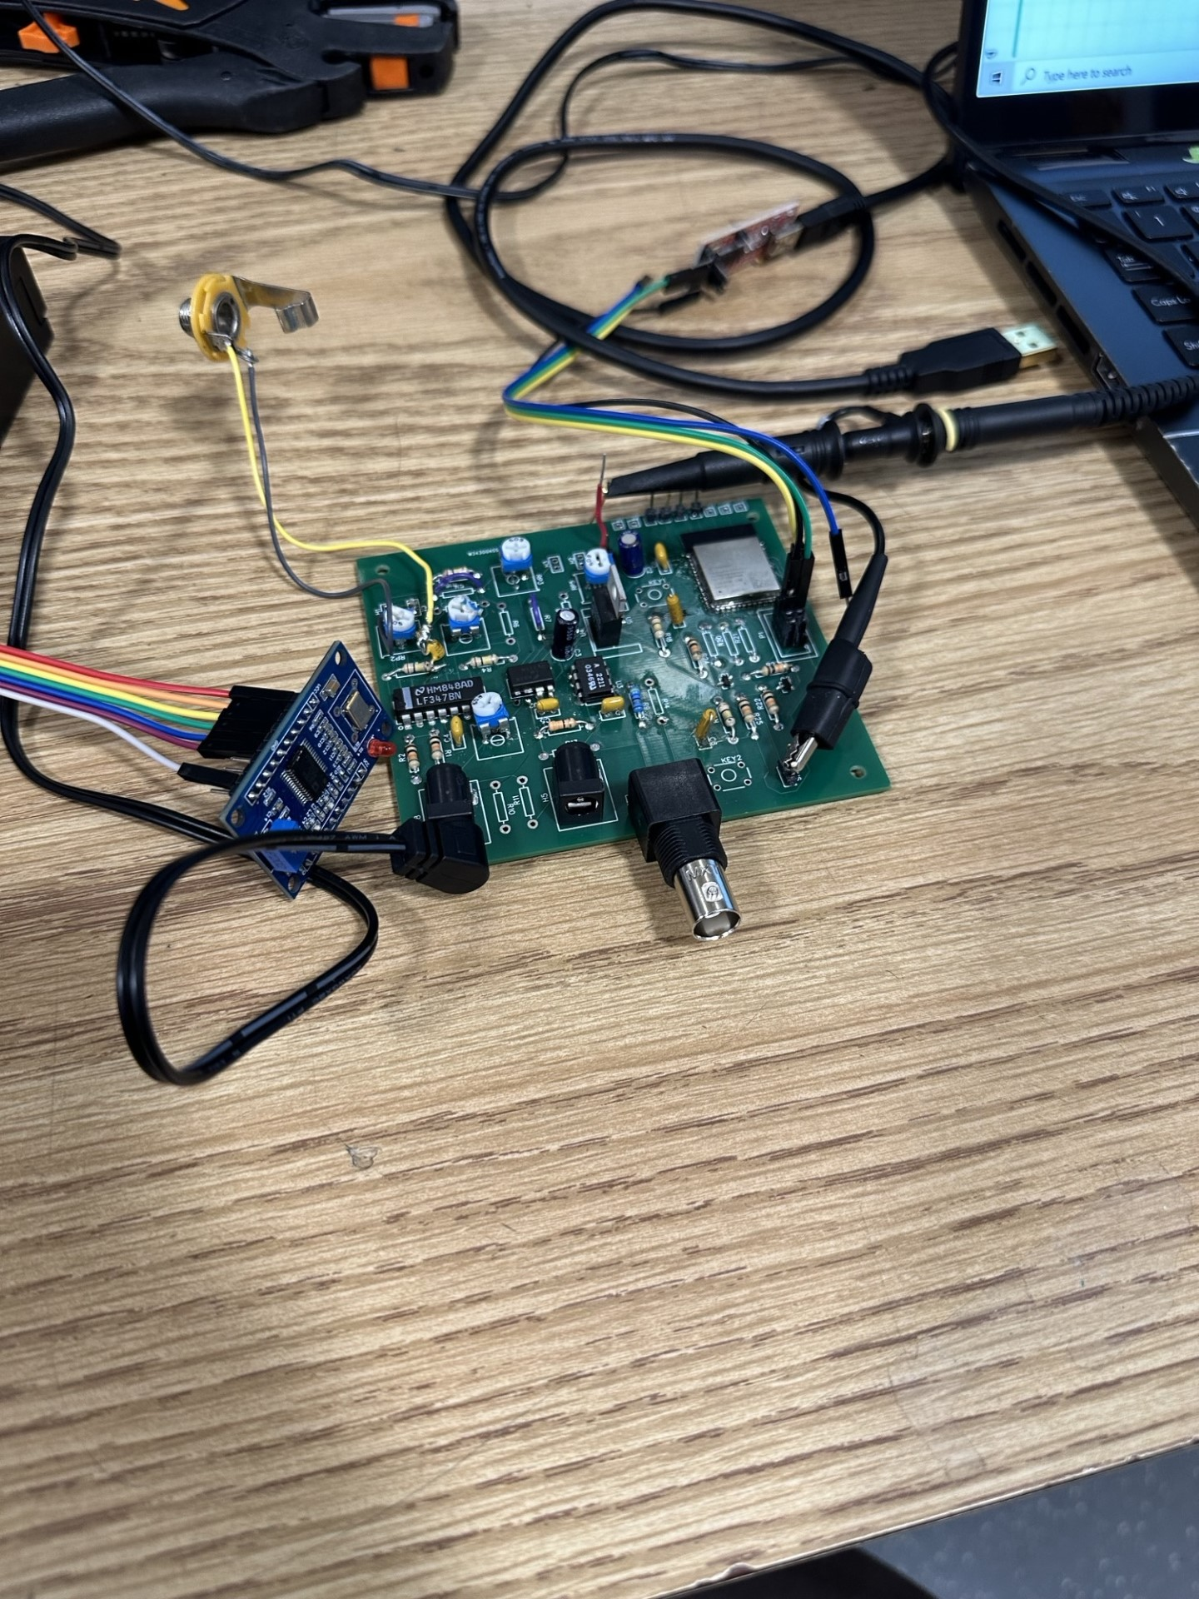

Figure 4: Completed Audio PCB with AD9850 Module.

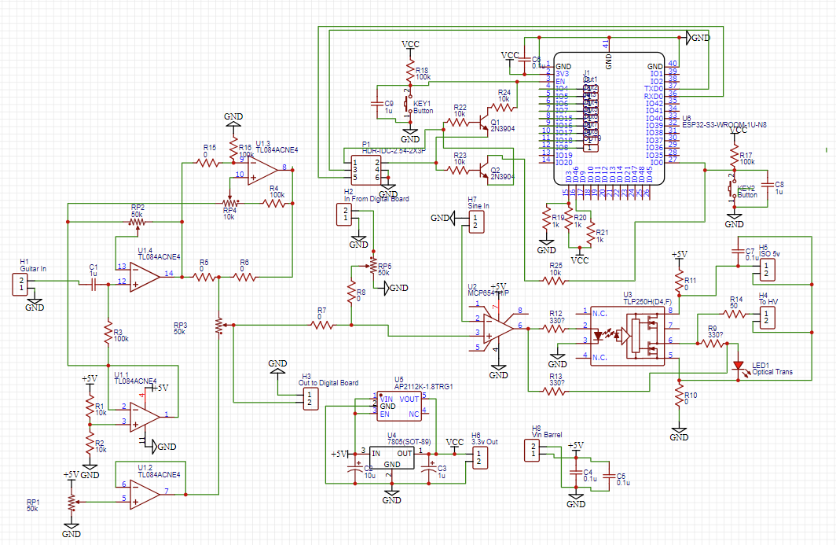

Figure 5: Low Voltage Board Circuit Schematic. Comparator replaced with LM311-N, Optocoupler replaced with HCPL-2211. R5, R7, R10, R11, and R14 were connected in final design, R15, R6, R8, R13, and R9, were unnecessary and remained unconnected

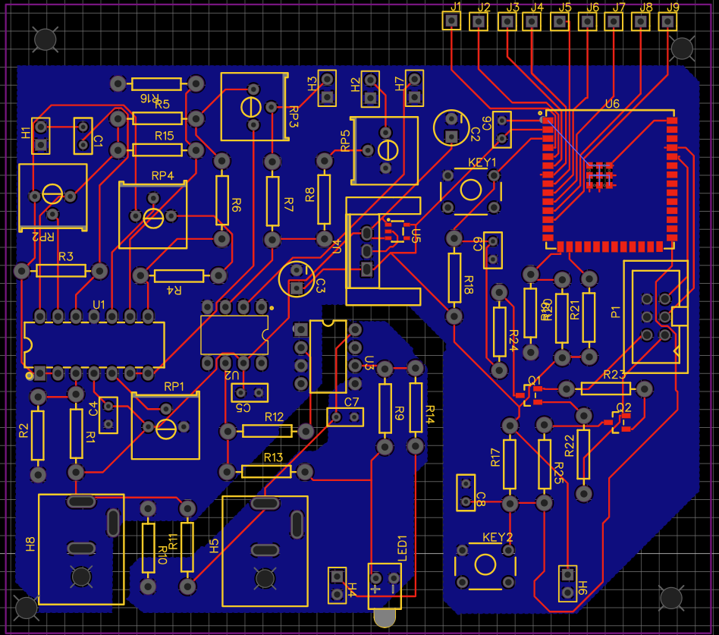

Figure 6: Low Voltage Board PCB Layout.

## 2.3 Power Subsystem

The power subsystem, like the audio subsystem, had its own dedicated PCB. The system draws power from AC mains at 120 V, then uses a Variac to step the voltage down to a variable level - indoor tests were performed stepping voltage down to 10-15 V. This output is then sent into the power PCB. The system uses a rectifier to filter this AC voltage waveform, and then uses a capacitive filter to transform the signal into a steady DC voltage, 20V for indoor tests. Our outdoor tests were able to reach a DC voltage of 30 V before causing faults in the primary winding. A circuit schematic with power, filtering, and switching is shown below:

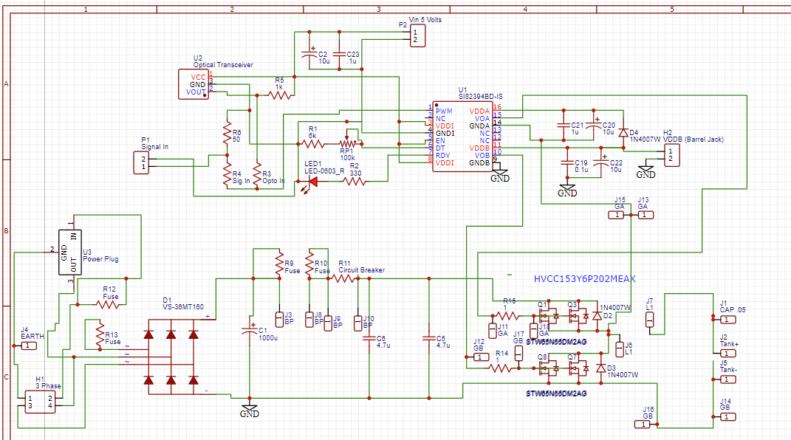  
Figure 7: Power Board Schematic. R4 was connected, Circuit breaker was shorted, and R3, R5, and R6 were unnecessary and left unconnected.

## 2.4 Switching Subsystem

This DC voltage is fed into a half bridge switching configuration, which uses two power MOSFETs controlled by an isolated gate driver module. The gate driver uses the signal from the aforementioned audio processing board to switch the MOSFETs on and off to interrupt the DC voltage, generating a pulse wave at the resonant frequency that is modulated by the desired audio input. The output of this switching configuration is sent into a specially developed tank circuit on the coil assembly system.

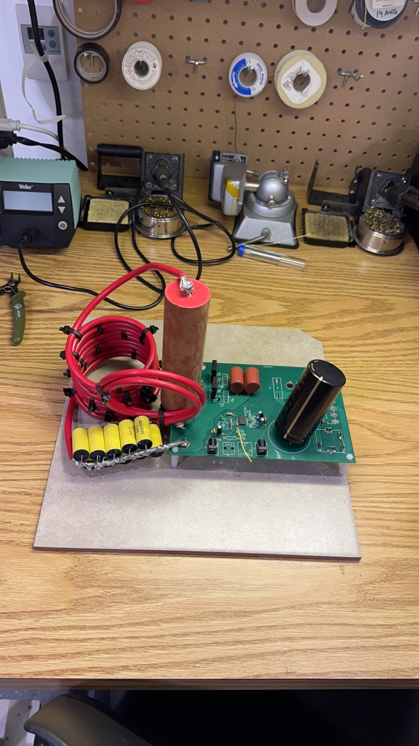

Figure 8: Power PCB, including power and switching.

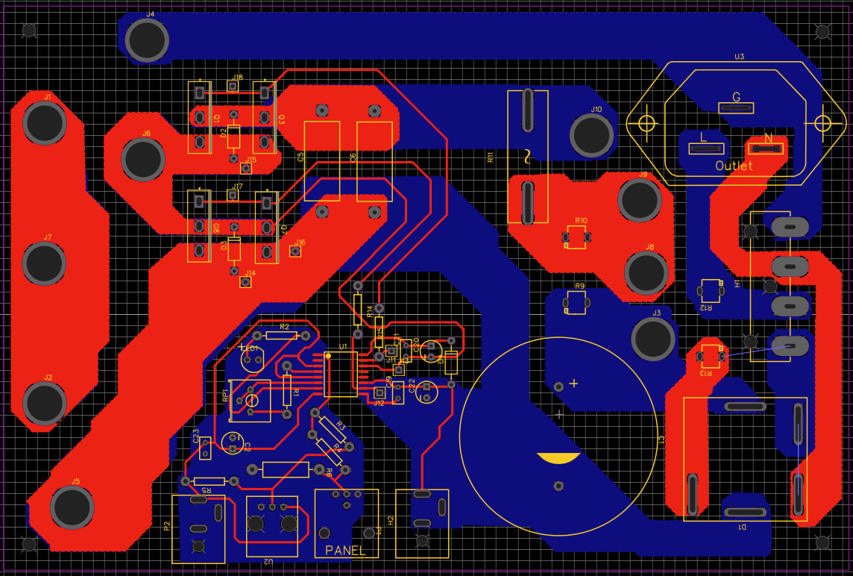

Figure 9: Power Board Layout.

In choosing gate drivers, we had a number of important considerations to influence our decision. First, the gate drivers need to be fully isolated, as there could not be any possibility of power transfer from the high-voltage board to the low-voltage board for fear of injuring the user. We designed this board to handle a DC rail of up to 400 V, so isolation on the gate drivers needed to be much higher than this.

Another important consideration was bandwidth. The gate drivers needed to be able to provide a variable pulse wave in the ballpark of 300 kHz. They also need to be able to supply enough instantaneous power to the gates of the transistors to turn them on quickly.

Due to these considerations, we ended up choosing the Skyworks SI82394CD4-IS High-Side/Low-Side Isolated Gate Drivers. These drivers provided 2500 V of isolation, could drive the MOSFETs we chose at the desired 12 V, and had a rise and fall time of 12 ns, well within the range we could tolerate. This single driver, with one input signal, could drive both MOSFETS simultaneously, and could dissipate 2.1 W of switching power if need be. They also provided dead time control to make sure that both MOSFETs were never simultaneously on. Thus, it was the right choice to enable our power board to function smoothly.

## 2.5 Coil Assembly Subsystem

The coil assembly is the apparatus that takes the electrical energy being supplied by the MOSFET half-bridge and converts it to sparks. There are two important parts to this system. First is the interface between the transistors and the primary winding, and the second is the secondary winding.

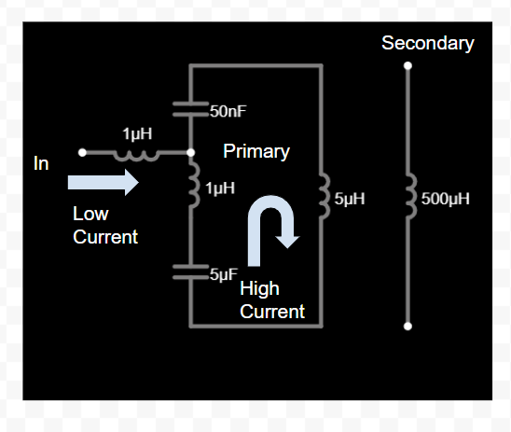

Figure 10: Tank Circuit Schematic.

The input from the MOSFET half-bridge is a variable pulse wave at the parallel resonance frequency of the tank. The input inductor (about 1 µH) consists of two turns of wire about 4 inches in diameter. This filters the input pulse wave to an approximate sine wave. At resonance, gain from DC rails to output AC Peak-To-Peak voltage was on the order of magnitude of 5-10. This was achieved due to the tank itself resonating, and the input supplying only necessary power to sustain oscillations. In this way, the transistors were protected from most of the high current. The 1 µH inductor in the tank was also 2 turns of wire about 4 inches in diameter. The orientation of this coil, the input coil and the primary winding were all made orthogonal to each other in order to prevent any mutual inductance between separate inductors, which was shown in simulation to be hurtful. The 50 nF capacitor in the tank was a 15k V power plant capacitor, and the 5 µF capacitor in the tank consisted of 10 individual 0.47 µF, 400 V polyester capacitors all connected in parallel. This allowed for maximum current flow in the tank.

Here is an LTSpice simulation for an idealized version of this circuit. The green curve is voltage gain from input to primary winding, and the blue curve is input current. This curve shows that we can run the circuit at a point where input current is minimal. Although output voltage could hypothetically increase, loss is minimized at this point, and we can increase power by increasing input voltage. Primary inductance is 10 µH in this simulation, as opposed to the 5 µH that we ended up with, but the curves will be similar regardless.

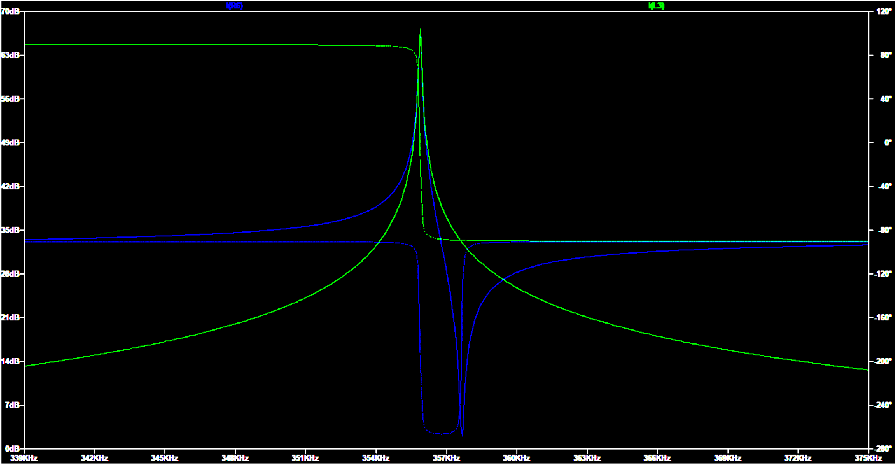  
Figures 11 & 12: Simulated Tank Outputs (left) and LTSpice Tank Simulation (right).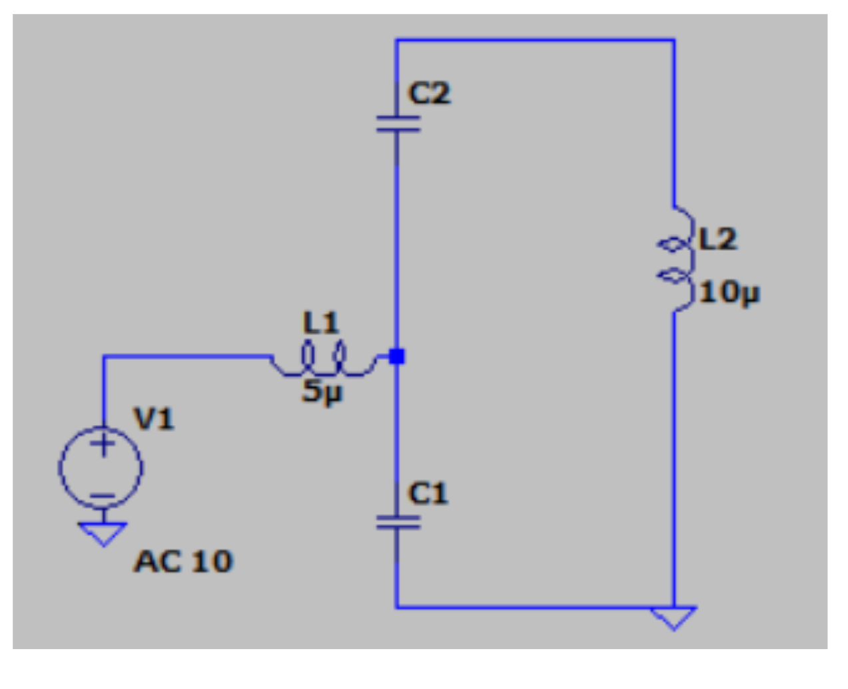

An important later addition to this circuit was the extra inductor in series with C1. This inductor was extremely important because otherwise C1 (at 5 µF) completely dominates the rest of the circuit if there is any loss at all in the tank. This loss was experimentally measured to be due to a parasitic resistance of about 0.4 Ω. This inductor allowed the two sides to be more balanced, and maximized voltage gain.

The primary winding of the Tesla Coil consists of 10 turns of wire with a diameter of around 4 inches. Theoretically, a minimal number of primary windings is desirable, as the voltage gain in a transformer is related to the turns ratio between primary and secondary. However, in practice, once the number of turns gets low enough, it is hard to push any energy at all into the primary winding. Thus, a compromise value of 5 µH, which corresponded to 10 turns, was used.

The secondary winding of the Tesla Coil has approximately 1,000 turns, and was reused from a 445 project in previous years. It was clear that the group who had used this coil in prior years had never gotten it to work, as there were no burn marks on the coil when we attained it. The coil assembly came with a 10-turn primary winding that was situated underneath the secondary winding, but we concluded that both the placement of this primary winding, and the very thin wire used were prohibitive to producing a working Tesla Coil. Thus, a new coil assembly was produced, as described above, with the same secondary winding.

Note that when an arc forms on the secondary winding, the characteristics of the tank circuit change. causing a lower primary voltage due to a slight shift in resonant frequency. This was predictable and non-consequential due to the hysteresis properties of ionized arc discharges. In air, an arc needs a very high voltage to form, but does not need high voltage to be sustained. Thus, the Tesla Coil, when not producing an arc will have the high voltages necessary to do so. When an arc is formed, much lower voltage can then be used to sustain it.

## 2.6 Tolerance Analysis

There were two important facets of tolerance analysis that we considered when designing this project. The first were absolute maximum tolerances. For example, the DC bus capacitor needed to be rated for at least 600 V, higher than the 400 V we designed our power board to withstand. The second were component values. To continue with this example, The DC bus capacitor needed to have a value at least in the hundreds of microfarads to prevent high ripple.

For absolute maximum tolerances, the power board was the main source of requirements. As stated before, the DC bus capacitor needed to be rated for at least 600 V, as with the MOSFETs and each of the 0.47 µF capacitors in parallel in the tank. The voltage across the 0.05 µF tank capacitor is even higher than the DC rails, thus we chose to rate it at 15 kV.

In addition, we included 10 A fuses in the power signal path to limit current. Our MOSFETS could handle a current of 60 A, but they also had higher current than the power input, which is why our fuses were rated much lower to protect the MOSFETS. All of the elements in the tank also had to handle even higher current. It was almost impossible to find accurate current tolerance measurements for capacitors, which factored into our choice of the power plant capacitor for the 0.05 µF side, and ten 0.47 µF polyester capacitors in parallel for the low side. This was the biggest we could do.

Similarly, we wanted to have high isolation tolerances for our gate drivers. We preferred an isolation of above 1 kV, much higher than potential DC rails, in case of any high voltage shorts. Our gate drivers ended up with isolation of 2.5 kV, which satisfied this requirement.

Tolerance in relation to component value was less important. We chose a DC bus capacitance of 470 µF as a good compromise between size and cost, and that kept our DC voltage ripple tolerable. Our main DC bus capacitor was electrolytic, so we added two parallel 4.7 µF ceramic capacitors to the DC bus as well to supply the high-frequency AC current generated in our transistors. This value had to be as high as possible to reduce stress on our electrolytic capacitor, and so was chosen to be at the top of the general capacitance range for non-electrolytics.

Our MOSFETS had an on resistance of about 0.04 Ω, this was well below what was needed, due to the low-current resonant nature of our tank. Either way, it kept power dissipation in the switching to a minimum which was important. The MOSFETs had rise/fall times in the ballpark of 10 ns, which was low enough for our target frequency of up to 300 kHz. Another important factor for the MOSFETS was heat tolerance. We constructed two steel heat sinks about 3 inches tall, 1.5 inches across, and ¼ inch thick, and attached them to the MOSFETS with an interface of thermal paste. Due to the low on-resistance of the MOSFETS, this was deemed to be sufficient for our purposes.

The value tolerances in the tank itself were also quite high. At some level, the inductances and capacitances inside correspond to a resonant frequency that can be arbitrarily generated digitally by the AD9850 board. As long as values are in the right order of magnitude, the circuit will work as intended.

Part tolerances on the low-voltage board were mostly to do with timing. The optocouplers we bought had high latency, as did the comparator we bought. These components had to be replaced with faster equivalent parts, all of which had latency in the tens of nanoseconds, a much more acceptable number given our target max frequency of 300 kHz. The rest of the board was low-frequency (audio range), and low-current, and thus part choice was mostly inconsequential.

# 3. Design Verification

The verification process was the final step in formulating a working design. This consisted of troubleshooting the various aspects of the power board, and then connecting them, and doing the same for the audio board. After this, both could be put together.

## 3.1 Power Subsystem

The power board had three main areas that needed to be verified. The first was the DC bus, including the voltage input, the rectifier, and the DC bus Capacitors. The second was the MOSFET portion, consisting of the switches themselves and the gate driver circuitry. The third was the coil assembly.

For testing the DC bus, we first applied a 25 VRMS, 60 Hz signal to the voltage input on the power board and tested the rectifier output waveform. This, as expected, was a full-rectified signal. Then we attached the large DC bus capacitor and checked the voltage ripple, which was higher than expected but manageable. This ripple was tested for a variety of resistive loads. For protection, both fuses were inserted into the DC bus circuitry. The circuit breaker was not added, as they or the fuses were individually sufficient. Instead, the circuit breaker was replaced by a wire.

## 3.2 Switching Subsystem

Next, the MOSFETs and gate drivers were tested. 10 V DC was applied to the DC bus using a voltage source, and a 5 V max, 0 V min square wave at 1 kHz was inputted into the gate driver input. The input side of the gate driver was powered using a 5 V wall wart, and the output side was powered using a 12 V wall wart. The output of the half-bridge was directly connected to a resistive load of 50 Ω. Originally, no output signal was detected, and this error was attributed to poor soldering on the reset pin of the gate driver. After this error was corrected, the gate driver and MOSFETs worked as designed. Latency was measured to be similar to that specified on the transistor and driver datasheets, and thus was small in relation to the 300 kHz max desired switching frequency. In the end, the patch point designated by R4 on the high voltage board was connected to provide the signal input. R3, R5, and R6 were unnecessary and left unconnected.

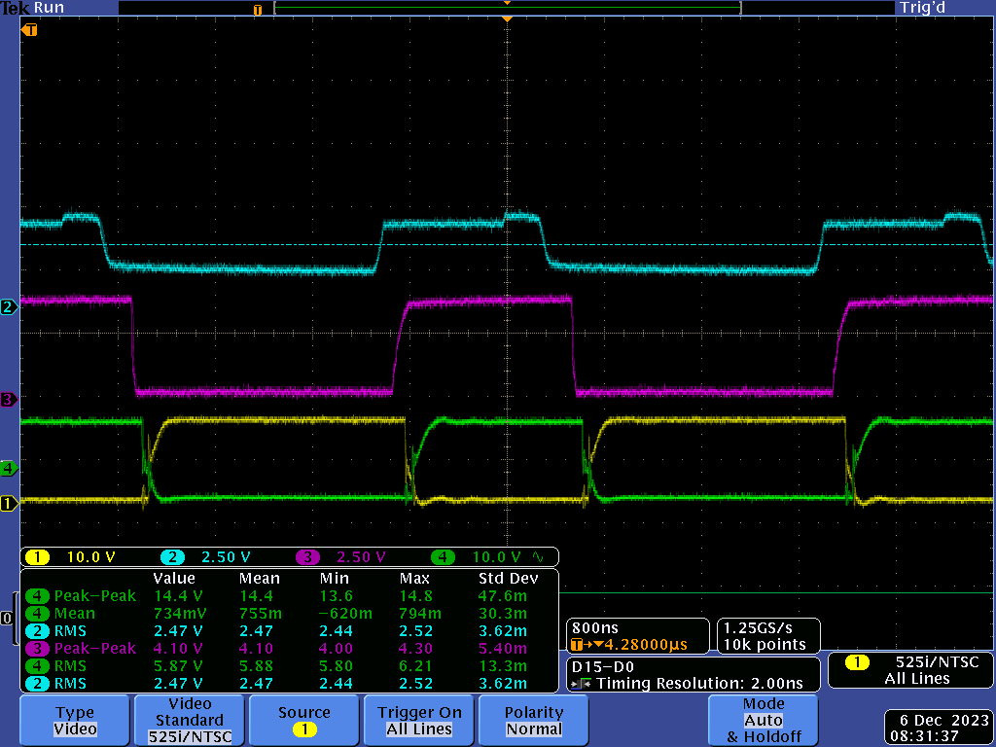

Figure 13: Switching Signals. Blue is audio board comparator output, purple is optocoupler output, yellow is high side gate signal, and green is low side gate signal.

## 3.3 Coil Assembly Subsystem

Finally, the coil assembly was tested. First, a sine wave input from a signal generator was provided to the tank, and voltage was measured on the primary winding. This input had a 50 ohm output impedance, which changed behavior slightly. Regardless, it was still possible to get a general understanding of resonance frequency. The original tank circuit that was built did not include the extra ~1 µH inductor on top of the 5 µF capacitor. It was impossible to get any output signal using the signal generator in this arrangement. To verify that this arrangement was flawed, the half-bridge output was wired to the tank, with a DC bus voltage of 1-5 V, and the frequency of switching was swept between 100 kHz and 500 kHz. It was discerned that even with this lower-impedance input, the loss in the tank due to parasitic resistance was such that the 5 µF capacitor completely dominated the other components, and thus the tank wasn’t functional.

To fix this, the 1 µH inductor was added into the loop that formed the tank. Then, the previous process was repeated again. This time around, voltage gain was observed, even with the signal generator as the input. This would make sense, as at parallel resonance, current input should be relatively low. After this, the MOSFETs were connected to the tank instead, and frequency was swept to minimize input current for a given pulse width and DC bus voltage. All of this was done at low voltage to lower risk of damage to electrical components. Once this parallel resonance was found, DC bus voltage was increased. It was found that power dissipation in the MOSFETS was manageable and the heat sinks were sufficient. The MOSFETs never became more than warm to the touch. There’s a chance at voltages higher than we tested that heat stress could occur, but the 0.04 Ω on-resistance of the MOSFETs make this unlikely for currents under 10 A. Overall, as seen in **Figures 14 & 15,** we found that for a 20 V DC Bus voltage, DC input current was 387 mARMS, and tank input current was 1.48 ARMS. In similar testing, tank input voltage was 10 V peak to peak, which was amplified to a primary winding voltage of around 70 V peak to peak, which signified significant voltage gain from the tank input. This relationship was found to be roughly linear in relation to both DC bus voltage, and input signal fundamental harmonic amplitude.

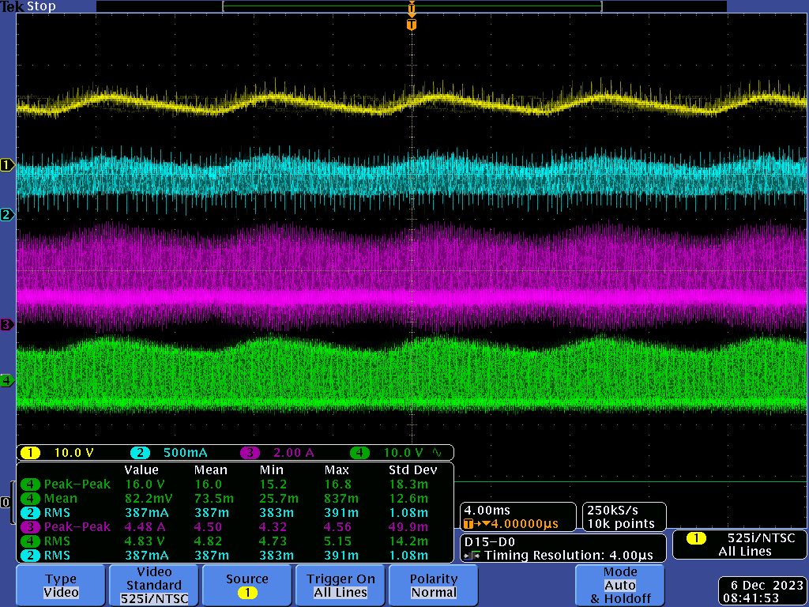

Figure 14: Tank Circuit Waveforms. Yellow is DC bus voltage, blue is DC switching input current, purple is tank input current, and green is tank input voltage.

After this test was successful, the circuit could now be tested with the secondary winding in place. It was found that the secondary winding worked best when the primary winding was placed midway between the top and bottom, so a wooden stand was constructed to achieve this goal. It was found that the resonant characteristics of the tank remained roughly the same when the secondary was open circuited, but when the secondary was arcing or shorted, the resonance would change due to induced voltage in the primary from the secondary. This was deemed to be acceptable, due to the low voltage needed to maintain an arc in relation to the voltage needed to create one. Small sparks were first visible with a DC bus voltage of 20 V. These sparks grew larger as DC bus voltage was increased, and with a DC bus voltage of around 30-35 V in an outdoor test, we were able to achieve our goal of 3-5 centimeter sparks.

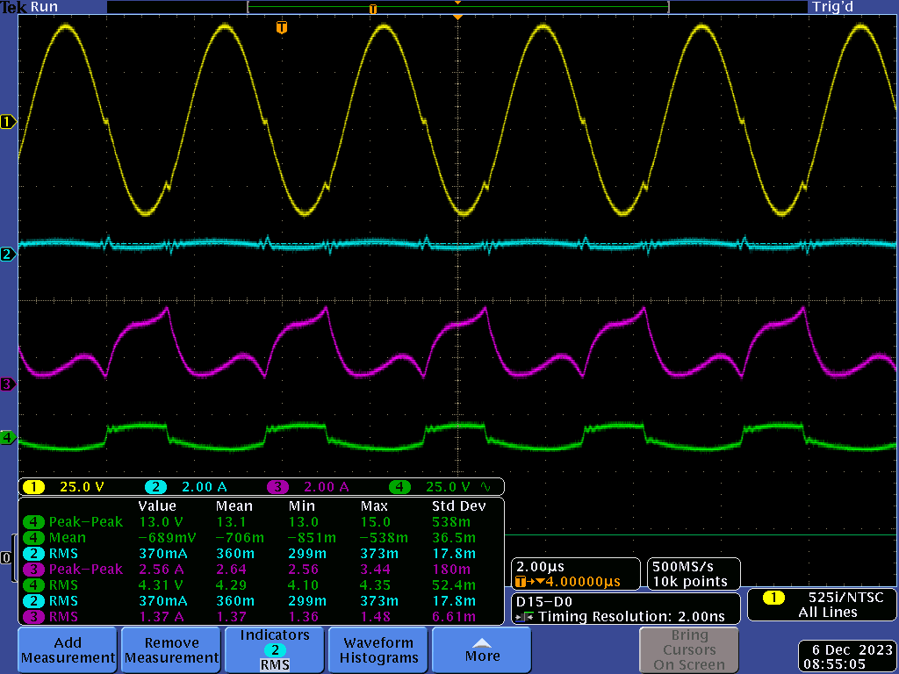

Figure 15: Tank circuit inputs and outputs. Yellow is primary winding voltage, blue is switching input current, purple is tank input current, and green is tank input voltage.

## 3.4 Audio Processing Subsystem

Once the components on the high voltage board were tested, focus shifted to the Audio board. The first thing to be tested was the audio input. A signal generator outputting a 100 mV 1KHz sine wave was inputted, and the various amplifier outputs were probed. After a ground fault at the input was bypassed, all performed as designed. Then, a high frequency ~300 kHz signal was inputted from the signal generator into the comparator input to generate a PWM signal. It was found that the comparator we ordered did not have anywhere near enough bandwidth to support the signal. Thus, a new comparator, the LM311-N was selected, with similar pinout. This worked successfully with minor changes

A Fiber-Optic link output was then tested on the audio board, being powered from the new comparator. It was found that the latency in the Fiber-Optic link was high enough to be problematic, in the ballpark of 1-10 µs of delay time, and very dependent on input and output impedance.

To solve this, an alternative plan utilizing an optocoupler was attempted instead. The optocoupler we had purchased also failed to work. This was replaced with a HCPL-2211 optocoupler with a near-identical pinout which worked as intended. This optocoupler output was connected via coaxial cable to the high voltage board. This maintained 2 layers of galvanic isolation between the low-power and high-power side. Overall R5, R7, R10, R11, and R14 were connected on the low voltage board (All of these except R14 were actually wires, R14 was 50Ω). This meant that R15, R6, R8, R13, and R9, were unnecessary and remained unconnected.

Finally, verification on the output of the AD9850 was performed. It was found that it could output a sine wave with a frequency accuracy of ±1 kHz. This was deemed to be satisfactory, and the AD9850 was then connected to the circuit. The ESP32 chip on the low voltage board for the AD9850 could not be successfully implemented. A devkit was successfully used instead.

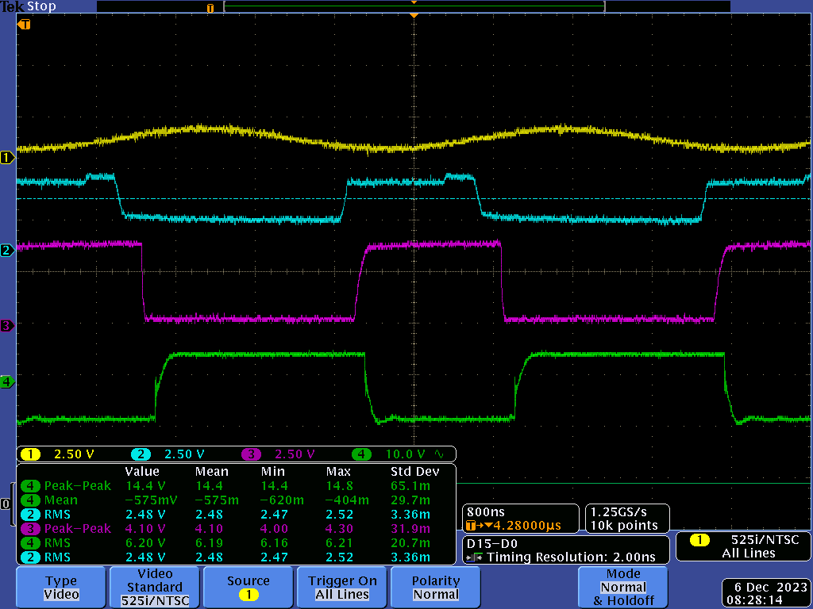

Figure 16: Audio Board/Switching Waveforms. Yellow is AD9850 resonant frequency, blue is comparator output, purple is optocoupler output, and green is high side MOSFET gate signal.

Now that all the parts of the circuit were satisfactorily functioning, the entire project could be tested. The entire setup was brought outside and worked as specified. The guitar input was audible due to the sparks from the secondary winding, which could reach 3-5 centimeters. Overall, this project, against all odds, was a resounding success.

# 4. Costs

## 4.1 Parts

Table 1 (below): Project Parts List

| **Part Name** | **Manufacturer** | **Cost** |
| --- | --- | --- |
| Fiber Optic Receiver IF-D95T | Infineon | $9.18 |
| Fiber Optic Transmitter  IF-E96E | Infineon | $7.32 |
| Fiber Optic Cable  FM65025 | Cliff Electronics | $5.10 |
| Power Entry Connector  6600.4315 | Schurter | $2.86 |
| Diode Rectifiers (10x)  637-1N4007 | Diotec | $1.25 |
| 3-phase bridge rectifier (2x)  [637-DB35-10](https://www.mouser.com/ProductDetail/637-DB35-10) | Diotec | $9.86 |
| DC Power Connectors (5x)  [474-PRT-10811](https://www.mouser.com/ProductDetail/474-PRT-10811) | Sparkfun | $4.75 |
| Cartridge Fuses (20x)  530-5SF10-R | Littelfuse | $4.66 |
| Fuse Clips (10x)  [576-52000001009](https://www.mouser.com/ProductDetail/576-52000001009) | Littelfuse | $1.67 |
| Circuit Breaker (2x)  562-QLB10311B3N3BA | Qualtek | $4.90 |
| Aluminum Electrolytic Capacitor  [80-ALC70A102EL500](https://www.mouser.com/ProductDetail/80-ALC70A102EL500) | Kemet | $21.02 |
| Gate Drivers (2x)  [634-SI82394CD4-IS](https://www.mouser.com/ProductDetail/634-SI82394CD4-IS) | Skyworks | $12.96 |
| MOSFET N-CH 650V 60A TO247 (4x) | STMicroelectronics | $44.96 |
| HCPL-2211 | Avago Technologies | $5.48 |
| LM311-N | TI | $3.96 |
| Tesla Coil (provided) |  | Estimated $40 |
| ESP32 microcontroller | Espressif | $11.99 |
| TL074 op amp | TI | $0.65 |
| Circuit Boards |  | ~$30 |
| Labor |  | $40 per hour * 220 hrs * 2 members = $17,600 |
| **Total** |  | $17,822.57 |

## 4.2 Labor

Table 2 (below): Labor Breakdown

| **Category** | | | **Hours per person** | |
| --- | --- | --- | --- | --- |
|  | | | Griffin | David |
| Circuit Design and Construction | | | 50 | 70 |
| Testing and Debug | | | 100 | 100 |
| Logistics/Documentation | | | 70 | 50 |

Both of us spent around 20 hours per week working on this project, a significant portion of both of our time. We were highly motivated to complete the project within the time constraints, and as such both of us dedicated a large amount of our time to implementing this project. For a project that lasted 11 weeks, this amounted to around 220 hours of labor per person.

# 5. Conclusion

## 5.1 Ethical considerations

Our group acted in accordance with the IEEE code of ethics. We established a process to review and revise all software and hardware designs that took everyone’s considerations into account. We made sure to follow course guidelines for feedback and worked with our TA mentor, Jason, closely. In accordance with the ethics code, we outlined that we expect this tesla coil to be used in a live music performance setting, and not in other industries such as the military. Other ethical concerns with this project involve user safety; in the next section we outline our safety concerns and precautions we took to ensure no team members or spectators were harmed or injured.

## 5.2 Safety

We considered potential safety issues regarding the use and design of the Tesla Coil, and have outlined below precautions and safety measures that we will take in order to prevent any potential risks. According to IEEE Standard code, high voltages constitute voltages over 1kV[4]. Our control circuits do not reach voltage this high, however we do feel taking a number of these precautions is still necessary. The precautions taken are detailed in the list below.

It is important to note that the standard only applies to voltage sources “with sufficient energy to cause damage.” For example, a capacitor of 0.05 µF with a voltage of 24 kV can hold just 14.4 J of energy: despite higher voltage, the energy is quite low. We determined that the frequency we used, around 350 kHz, is too high to cause significant damage to human nerve cells[5]. Extreme caution was exercised when dealing with all parts of this circuit.

We closely followed the Safety Guidelines outline on the ECE 445 web page, and also completed several safety training sessions regarding high voltage and high power experiments. We also studied the guidelines of a previous senior design project involving a tesla coil, and took inspiration from several of their safety precautions. The full safety procedures used for this project are outlined below:

* The tesla coil will never be turned on indoors, it will be tested outside with multiple group members present using an outdoor wall outlet, with cones to create a circle of safety to keep bystanders away. We will use insulating gloves when operating.
* We will keep everyone at least 10 ft away while the coil is active.
* The voltage can reach up to 100 kV (albeit low current) so all sparks will be directed onto a grounding rod 3-5 cm away, a general rule is that each 30 kV can bridge a 1 cm gap [3].
* The coil will have several fuses at the power supply circuit.
* The cable from the guitar will use an optocoupler so that the user is not connected to a circuit with any power electronics.
* The gate driver will provide 2.5 kV of isolation for an additional layer of protection

## 5.3 Accomplishments

Ultimately, we were able to get all aspects of this project fully functional before the deadline. We were also able to devise two special characteristics for the project that, as far as we can tell, have never been done before with tesla coil constructions. The first, as mentioned previously, is using pulse-width modulation rather than the logical AND operator to combine the resonant and audio frequencies. This gave us a greater audio fidelity than other hobbyist tesla coils. Next, and likely the most innovative aspect of our design, is our specialized tank circuit. This too, as far as we can tell, has never been done before, and allows us to drive the coil at significantly higher voltage and current if we so desire, without the risk of burning up the MOSFETs. Switching is usually the primary limiting factor in tesla coil designs, so the fact that we are able to operate our coil with significantly less stress on the switch makes our coil design more efficient than other designs with a greater power ceiling in theory.

Because we were able to not only recreate popular coil designs, but add features such as live input audio, and simultaneously improve upon common designs with PWM and a specialized tank circuit, this project marks a significant accomplishment in both of our engineering careers. This project was the most significant test of our engineering skills we have encountered so far, and, as the result of determination, curiosity, and countless hours of labor, this project resulted in a complete success.

## 5.4 Future work

One area of future study could be upgrading the microcontroller. Our design uses a development kit, but future designs can and should use a fully integrated microcontroller included on the audio PCB.

Finally, our design was overbuilt on purpose - we used a relatively small coil assembly because we wanted to ensure functionality, but the circuit itself can tolerate much higher voltages and currents than what we used to operate it. During our limit tests after the final demo, the coil assembly began to fail past 30 V of input, but nothing on the circuit was damaged at all. This confirms that the limiting factor in this design is not the circuit, but the coil assembly. For future designs, we plan to connect the circuit to a larger coil to generate more pronounced sparks with a greater audio volume. By upgrading the coil assembly, the design could become even more visually appealing and exciting to watch.

## 5.5 Special Thanks

We would like to give a special thanks to Jason Paximadas, Arne Fliflet, and Arijit Banerjee for being invaluable to the overall development of the project. We couldn’t have accomplished this without their mentorship and guidance.

# References

[1] J. Long; et al, “Improving the Musical Expressiveness of Tesla Coils with Software,” *University of North Texas,* Oct. 1, 2015. [Accessed Sep 27, 2023].

[2] E. Jones; A. Wright, “How Many Watts Can an Outlet Handle?” *Galvin Power,* Sep. 1, 2023. Available at: <https://www.galvinpower.org/how-many-watts-can-an-outlet-handle/>. Accessed Sep 26, 2023.

[3] J. Papiewski, “How to Calculate Voltage by Spark Gaps,” *Sciencing,* Mar. 13, 2018. Available at: <https://sciencing.com/calculate-30-kw-amps-7644913.html>. Accessed Sep 26, 2023.

[4] IEEE Standards Board, “IEEE Recommended Practices for Safety in High-Voltage and High-Power Testing”, *IEEE Power Engineering Society,* Mar. 19, 1992. Available at: <https://ieeexplore.ieee.org/stamp/stamp.jsp?arnumber=578032>. Accessed Oct 16, 2023.

[5] Sadaghdar, Mehdi, “Electric Pain Versus Frequency”. *Electroboom.* Aug. 31, 2015. Available at: <https://www.electroboom.com/?p=688> Accessed Oct 16, 2023.

# Appendix A Requirement and Verification Table

*Table 3 (below): Audio Processing Requirements Table*

| **Requirement:** | **Verification:** | **Verification Status**  **(Y or N)** |
| --- | --- | --- |
| Output pulse wave must be at resonant frequency in range 100k-400kHz with 1kHz granularity | Measure waveform frequencies with an oscilloscope | Y |
| Subsystem must output a signal of 12 ± 1V to the gate driver and switching subsystem | Use voltage probe to measure output | Y |
| Subsystem can create a pulse wave that is either pulses of the resonant frequency or a PWM wave where the resonant frequency is modulated with the audio frequency | Duty cycle can be measured using an oscilloscope to determine the ratio of the time the circuit is on vs off | Y |

*Table 4 (below): Power System Requirements Table*

| **Requirement:** | **Verification:** | **Verification Status**  **(Y or N)** |
| --- | --- | --- |
| After filtering, limit ripple voltage to 10% | Measure waveform with oscilloscope and observe the min to max voltage variation | Y |
| Voltage sent to switching must be able to reach at least 60V, and any value lower | Monitor using oscilloscope or DVM | Y |
| Circuit must be able to limit DC input current to to 10 ± 5A | Monitor using oscilloscope | Y |
| Subsystem must not trigger wall outlet circuit breaker: max wall outlet power is 1.5kW[2], so limit power consumption to below 1.5kW | Monitor outlet to ensure breaker is not triggered | Y |
| Capacitors must be discharged to below 10 volts 5 minutes after coil power is disconnected | Install bleeder resistors on capacitors and use voltage probe to test capacitor voltage | Y |

*Table 5 (below): Switching Requirements Table*

| **Criteria:** | **Verification:** | **Verification Status**  **(Y or N)** |
| --- | --- | --- |
| Limit Current Spikes through subsystem to 30A | Use oscilloscope to ensure operating current does not exceed the set limit | Y |
| Subsystem must be able to be prevented from reaching over 100 V on any power rails | Monitor voltage and use Variac to step down voltage if necessary | Y |
| Limit power consumed to 1kW | Measure current and voltage on DC Bus with current and voltage probes | Y |
| Limit subsystem temperature to T ≤ 100℃ | Use thermal camera to measure MOSFET temperatures after one minute of continuous operation | Y |

*Table 6 (below): Coil Assembly Requirements Table*

| **Requirement:** | **Verification:** | **Verification Status**  **(Y or N)** |
| --- | --- | --- |
| Prevent capacitors from being destroyed during operation | Visual inspection to ensure no capacitors break during coil operation | Y |
| Create sparks that are >2 cm in length | Measure if sparks reach grounding rod or if they break off in the wrong directions | Y |
| Circuit is protected - all sparks are directed to grounding rod, no arcing to surroundings or the rest of the system | Visual inspection during coil operation | Y |